**Supplementary Figures**

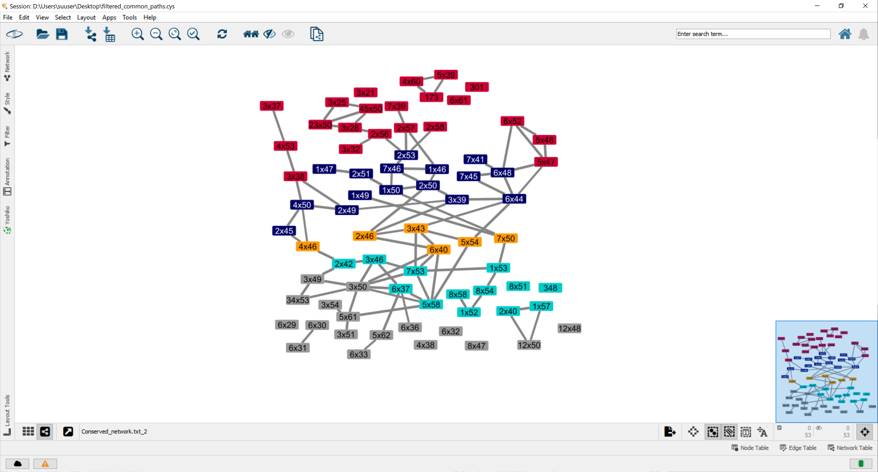

**Supplementary Figure 1: Selective pathways for activation containing all conserved residues**

This network contains complete list of conserved residues for each layer we demonstrated in Figure 2b. Each layer from top to bottom is represented with a different color. Some of the nodes are lack an edge due to the filtration step that we applied based on frequency of the information change between two residues.